VISVESVARAYA TECHNOLOGICAL UNIVERSITY

“JnanaSangama”, Belgaum -590014, Karnataka.

LAB RECORD

Bio Inspired Systems (23CS5BSBIS)
Submitted by
Dyuthi (1BM23CS097)
in partial fulfillment for the award of the degree of

BACHELOR OF ENGINEERING
in
COMPUTER SCIENCE AND ENGINEERING



B.M.S. COLLEGE OF ENGINEERING
(Autonomous Institution under VTU)
BENGALURU-560019
Aug-2025 to Dec-2025

B.M.S. College of Engineering,
Bull Temple Road, Bangalore 560019
(Affiliated To Visvesvaraya Technological University, Belgaum)
Department of Computer Science and Engineering
CERTIFICATE
This is to certify that the Lab work entitled “ Bio Inspired Systems (23CS5BSBIS)” carried out by Dyuthi (1BM23CS097), who is bonafide student of B.M.S. College of Engineering. It is in partial fulfillment for the award of Bachelor of Engineering in Computer Science and Engineering of the Visvesvaraya Technological University, Belgaum. The Lab report has been approved as it satisfies the academic requirements of the above mentioned subject and the work prescribed for the said degree.

Mayanka Gupta  Assistant Professor  Department of CSE, BMSCE | Dr. Kavitha Sooda  Professor & HOD  Department of CSE, BMSCE

Index
Sl.  No. | Date | Experiment Title | Page No.
1 |  | Genetic Algorithm for Optimization Problems
2 |  | Optimization via Gene Expression Algorithms
3 |  | Particle Swarm Optimization for Function Optimization
4 |  | Ant Colony Optimization for the Traveling Salesman Problem
5 |  | Cuckoo Search
6 |  | Grey Wolf Optimizer
7 |  | Parallel Cellular Algorithms and Programs

Github Link:
https://github.com/Dyuthiprasad/BIS_LAB_1BM23CS097

Lab Program 1

Problem Statement: To find the maximum value of a given mathematical function using a Genetic Algorithm. The algorithm simulates the process of natural selection by evolving a population of candidate solutions through selection, crossover, and mutation operations to obtain the optimal solution.

Algorithm:
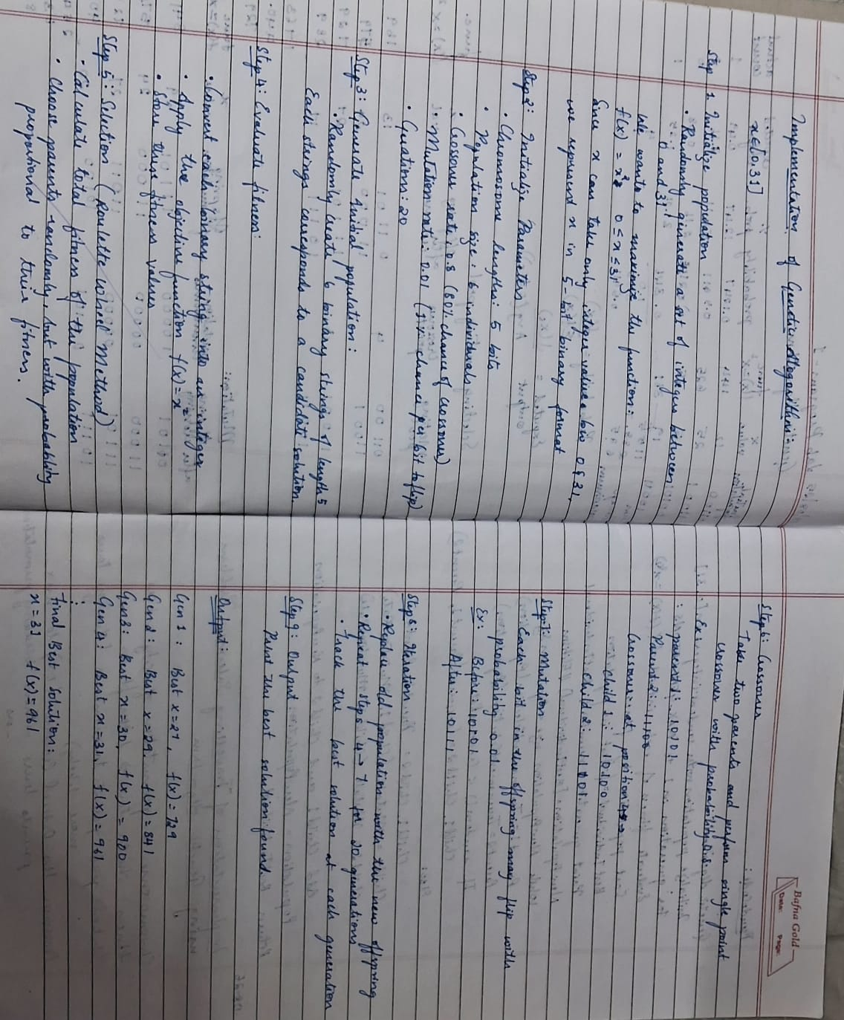

Code:

import random
import math
from typing import List, Tuple

City = Tuple[float, float]
Route = List[int]

def euclidean(a: City, b: City) -> float:
return math.hypot(a[0]-b[0], a[1]-b[1])

def route_length(route: Route, cities: List[City]) -> float:
# complete tour (wrap back to start)
dist = 0.0
for i in range(len(route)):
a = cities[route[i]]
b = cities[route[(i+1) % len(route)]]
dist += euclidean(a, b)
return dist

def fitness(route: Route, cities: List[City]) -> float:
# higher is better
return 1.0 / (1e-9 + route_length(route, cities))

def tournament_selection(pop: List[Route], cities: List[City], k: int = 3) -> Route:
contestants = random.sample(pop, k)
return max(contestants, key=lambda r: fitness(r, cities))

def ordered_crossover(parent1: Route, parent2: Route) -> Tuple[Route, Route]:
n = len(parent1)
a, b = sorted(random.sample(range(n), 2))
# child1: take slice from p1, fill remainder in p2 order
slice1 = parent1[a:b+1]
child1 = [None]*n
child1[a:b+1] = slice1
fill = [g for g in parent2 if g not in slice1]
idx = 0
for i in range(n):
if child1[i] is None:
child1[i] = fill[idx]
idx += 1
# child2 symmetric
slice2 = parent2[a:b+1]
child2 = [None]*n
child2[a:b+1] = slice2
fill = [g for g in parent1 if g not in slice2]
idx = 0
for i in range(n):
if child2[i] is None:
child2[i] = fill[idx]
idx += 1
return child1, child2

def swap_mutation(route: Route, mutation_rate: float = 0.2) -> Route:
r = route[:]
if random.random() < mutation_rate:
i, j = random.sample(range(len(r)), 2)
r[i], r[j] = r[j], r[i]
return r

# GA loop
def genetic_algorithm_tsp(
cities: List[City],
pop_size: int = 150,
generations: int = 500,
crossover_rate: float = 0.9,
mutation_rate: float = 0.2,
tournament_k: int = 3,
elitism: int = 1,
seed: int | None = None
):
if seed is not None:
random.seed(seed)

n = len(cities)
# initial population: random permutations
population: List[Route] = [random.sample(range(n), n) for _ in range(pop_size)]

best_route = min(population, key=lambda r: route_length(r, cities))
best_dist = route_length(best_route, cities)
history = [best_dist]

for gen in range(generations):
# sort by fitness descending
population.sort(key=lambda r: fitness(r, cities), reverse=True)
# elitism
new_pop: List[Route] = population[:elitism]

# produce children
while len(new_pop) < pop_size:
p1 = tournament_selection(population, cities, k=tournament_k)
p2 = tournament_selection(population, cities, k=tournament_k)
if random.random() < crossover_rate:
c1, c2 = ordered_crossover(p1, p2)
else:
c1, c2 = p1[:], p2[:]
c1 = swap_mutation(c1, mutation_rate)
c2 = swap_mutation(c2, mutation_rate)
new_pop.extend([c1, c2])

population = new_pop[:pop_size]

# track best
candidate = min(population, key=lambda r: route_length(r, cities))
cand_dist = route_length(candidate, cities)
if cand_dist < best_dist:
best_dist = cand_dist
best_route = candidate
history.append(best_dist)

# (optional) print progress sparsely
if (gen+1) % max(1, generations//10) == 0:
print(f"Gen {gen+1:4d} | best distance = {best_dist:.4f}")

return best_route, best_dist, history

if __name__ == "__main__":
# Example coordinates (you can replace with your own)
cities = [
(0,0), (1,5), (5,2), (6,6), (8,3),
(2,1), (7,7), (3,8), (9,1), (4,4),
(6,1), (2,7), (8,8), (1,9), (9,9)
]

best_route, best_dist, hist = genetic_algorithm_tsp(
cities,
pop_size=200,
generations=600,
crossover_rate=0.95,
mutation_rate=0.25,
tournament_k=4,
elitism=2,
seed=42
)

print("\nBest tour length:", round(best_dist, 4))
print("Best route (city indices):", best_route)

Lab Program 2

Problem Statement: To find the optimal solution of a given mathematical function using the Gene Expression Algorithm. The algorithm is inspired by the biological process of gene expression, where encoded genetic information evolves through selection, crossover, mutation, and expression to produce optimal or near-optimal solutions for complex optimization problems.
Algorithm:

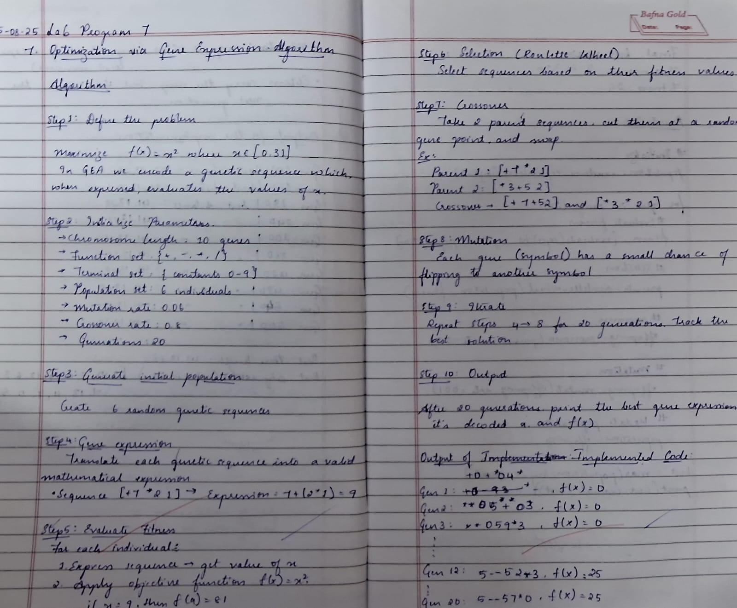

Code:

import random
import math

# PARAMETERS
POP_SIZE = 6
CHROM_LENGTH = 7 # length of genetic sequence
FUNCTIONS = ['+', '-', '*']
TERMINALS = [str(i) for i in range(10)] # constants 0–9
CROSSOVER_RATE = 0.8
MUTATION_RATE = 0.1
GENERATIONS = 20

# HELPER FUNCTIONS
def random_gene():
"""Return a random gene (either function or terminal)."""
if random.random() < 0.4:
return random.choice(FUNCTIONS)
return random.choice(TERMINALS)

def create_individual():
"""Generate a random chromosome (sequence)."""
return [random_gene() for _ in range(CHROM_LENGTH)]

def decode_expression(chromosome):
"""Convert chromosome into a valid arithmetic expression."""
expr = ""
for gene in chromosome:
expr += gene
return expr

def evaluate(chromosome):
"""Evaluate chromosome by expressing it as integer x, then f(x)=x^2."""
expr = decode_expression(chromosome)
try:
# Evaluate safely
x_val = int(eval(expr))
except Exception:
return 0 # invalid expression
if x_val < 0 or x_val > 31: # constrain to problem domain
return 0
return x_val**2

def roulette_wheel_selection(pop, fitnesses):
"""Select one individual using roulette wheel."""
total_fit = sum(fitnesses)
if total_fit == 0:
return random.choice(pop)
pick = random.uniform(0, total_fit)
current = 0
for i, f in enumerate(fitnesses):
current += f
if current > pick:
return pop[i]

def crossover(parent1, parent2):
"""Single point crossover."""
if random.random() > CROSSOVER_RATE:
return parent1[:], parent2[:]
point = random.randint(1, CHROM_LENGTH - 1)
child1 = parent1[:point] + parent2[point:]
child2 = parent2[:point] + parent1[point:]
return child1, child2

def mutate(chromosome):
"""Mutate chromosome by flipping a gene."""
for i in range(len(chromosome)):
if random.random() < MUTATION_RATE:
chromosome[i] = random_gene()
return chromosome

# MAIN LOOP
population = [create_individual() for _ in range(POP_SIZE)]

for gen in range(GENERATIONS):
fitnesses = [evaluate(ind) for ind in population]
best_index = fitnesses.index(max(fitnesses))
best = population[best_index]
print(f"Gen {gen+1}: Best = {decode_expression(best)}, f(x) = {max(fitnesses)}")

# New population
new_population = []
while len(new_population) < POP_SIZE:
p1 = roulette_wheel_selection(population, fitnesses)
p2 = roulette_wheel_selection(population, fitnesses)
c1, c2 = crossover(p1, p2)
c1 = mutate(c1)
c2 = mutate(c2)
new_population.extend([c1, c2])
population = new_population[:POP_SIZE]

# Final result
fitnesses = [evaluate(ind) for ind in population]
best_index = fitnesses.index(max(fitnesses))
best = population[best_index]
print("\nFinal Best Solution:")
print("Chromosome:", decode_expression(best))
print("Fitness:", max(fitnesses))

Lab Program 3:

Problem Statement: To find the optimal value of a given mathematical function using the Particle Swarm Optimization algorithm. The algorithm mimics the social behavior of particles moving in a search space, adjusting their positions based on individual and collective experiences to converge toward the best solution.

Algorithm:

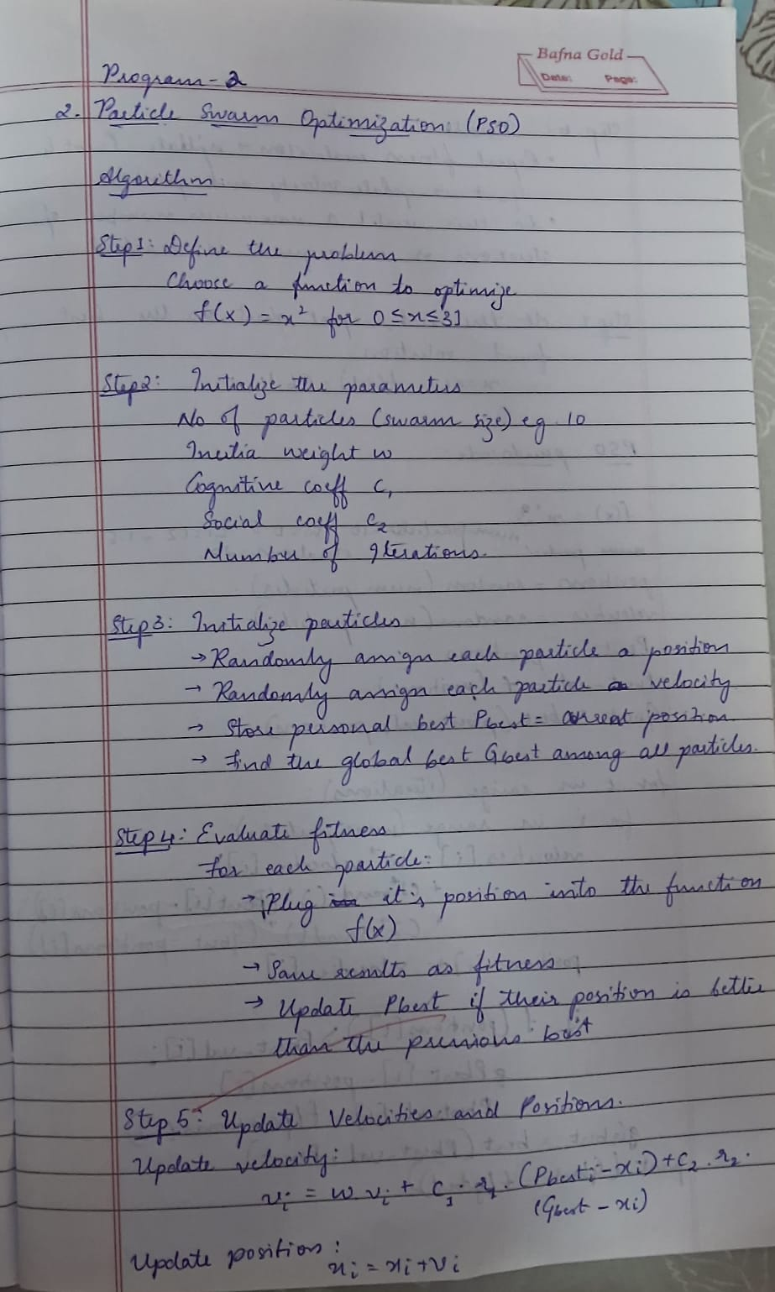

Code:

import numpy as np

class PSO:
def __init__(self, func, dim, bounds, swarmsize=30, iterations=100,
w=0.7, c1=1.5, c2=1.5, vel_clamp=None, seed=None):
"""
func : callable(x) -> scalar (objective to minimize). x is 1D numpy array length dim.
dim : dimensionality of the search space (int)
bounds : tuple (lower, upper) or array-like shape (dim,2)
swarmsize : number of particles
iterations : number of iterations (generations)
w, c1, c2 : PSO hyperparameters
vel_clamp : None or (vmin, vmax) to clamp velocities
seed : random seed for reproducibility
"""
self.func = func
self.dim = dim
self.swarmsize = swarmsize
self.iterations = iterations
self.w = w
self.c1 = c1
self.c2 = c2
self.vel_clamp = vel_clamp
if seed is not None:
np.random.seed(seed)

# handle bounds
if isinstance(bounds, tuple) and len(bounds) == 2 and np.isscalar(bounds[0]):
lo = np.full(dim, bounds[0], dtype=float)
hi = np.full(dim, bounds[1], dtype=float)
else:
arr = np.array(bounds, dtype=float)
if arr.shape == (dim, 2):
lo, hi = arr[:, 0], arr[:, 1]
else:
raise ValueError("bounds must be (low, high) scalars or array-like shape (dim,2)")
self.lb = lo
self.ub = hi

# initialize particles
self.pos = np.random.uniform(self.lb, self.ub, (swarmsize, dim))
# small random initial velocities
self.vel = np.random.uniform(-np.abs(self.ub - self.lb), np.abs(self.ub - self.lb), (swarmsize, dim)) * 0.1

# personal best positions and values
self.pbest_pos = self.pos.copy()
self.pbest_val = np.array([self.func(p) for p in self.pos])

# global best
best_idx = np.argmin(self.pbest_val)
self.gbest_pos = self.pbest_pos[best_idx].copy()
self.gbest_val = self.pbest_val[best_idx]

# history (optional)
self.history = []

def step(self):
r1 = np.random.rand(self.swarmsize, self.dim)
r2 = np.random.rand(self.swarmsize, self.dim)

cognitive = self.c1 * r1 * (self.pbest_pos - self.pos)
social = self.c2 * r2 * (self.gbest_pos - self.pos)

# velocity update
self.vel = self.w * self.vel + cognitive + social

# velocity clamping
if self.vel_clamp is not None:
vmin, vmax = self.vel_clamp
self.vel = np.clip(self.vel, vmin, vmax)

# position update
self.pos = self.pos + self.vel

# boundary handling (reflective)
out_low = self.pos < self.lb
out_high = self.pos > self.ub
if np.any(out_low) or np.any(out_high):
# reflect position inside and invert velocity component
self.pos = np.where(out_low, self.lb + (self.lb - self.pos), self.pos)
self.pos = np.where(out_high, self.ub - (self.pos - self.ub), self.pos)
self.vel = np.where(out_low | out_high, -self.vel, self.vel)

# evaluate
vals = np.array([self.func(p) for p in self.pos])

# update personal bests
improved = vals < self.pbest_val
if np.any(improved):
self.pbest_pos[improved] = self.pos[improved]
self.pbest_val[improved] = vals[improved]

# update global best
best_idx = np.argmin(self.pbest_val)
if self.pbest_val[best_idx] < self.gbest_val:
self.gbest_val = self.pbest_val[best_idx]
self.gbest_pos = self.pbest_pos[best_idx].copy()

return self.gbest_pos, self.gbest_val

def optimize(self, verbose=False):
for it in range(self.iterations):
gpos, gval = self.step()
self.history.append(gval)
if verbose and ((it + 1) % max(1, self.iterations // 10) == 0 or it == 0):
print(f"Iter {it+1:4d}/{self.iterations} best = {gval:.6g}")
return self.gbest_pos, self.gbest_val

# ---------- Example objective functions ----------
def sphere(x):
# simple convex function, global min at 0
return np.sum(x**2)

def rastrigin(x):
# multimodal benchmark (min at 0)
A = 10.0
return A * x.size + np.sum(x**2 - A * np.cos(2 * np.pi * x))

# ---------- Example usage ----------
if __name__ == "__main__":
dim = 5
bounds = (-5.12, 5.12) # common Rastrigin bounds

# choose the objective:
objective = rastrigin # or sphere

pso = PSO(func=objective,
dim=dim,
bounds=bounds,
swarmsize=50,
iterations=300,
w=0.729, # often used value (constriction factor style)
c1=1.49445, # common PSO tuning constants
c2=1.49445,
vel_clamp=(-2.5, 2.5),
seed=42)

best_pos, best_val = pso.optimize(verbose=True)

print("\nSolution found:")
print("best position:", best_pos)
print("best value :", best_val)

# optional: inspect history (list of best values per iteration)
try:
import matplotlib.pyplot as plt
plt.plot(pso.history)
plt.xlabel("Iteration")
plt.ylabel("Best objective value")
plt.title("PSO Convergence")
plt.grid(True)
plt.show()
except Exception:
# matplotlib may not be available — that's fine.
pass

Lab Program 4:

Problem Statement: To find the shortest possible route that visits all given cities exactly once and returns to the starting city using the Ant Colony Optimization algorithm. The algorithm simulates the foraging behavior of ants, where artificial ants build solutions based on pheromone trails and heuristic information, gradually improving toward the optimal path through repeated iterations.

Algorithm:

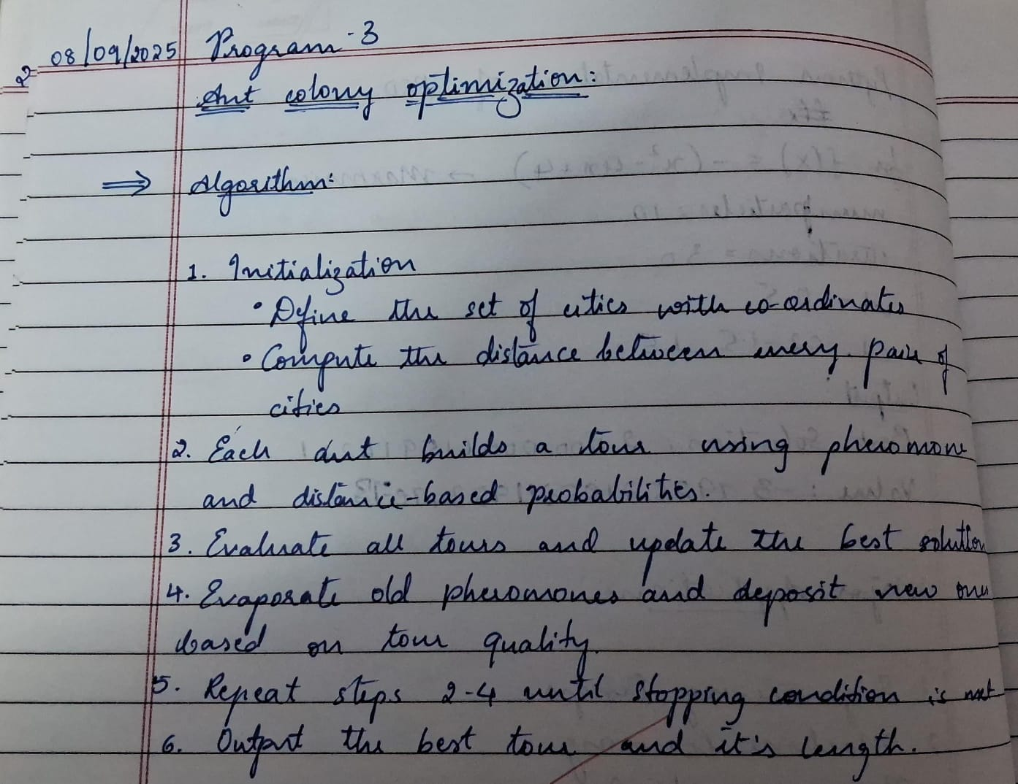

Code:

import numpy as np
import random

# Step 1: Define the problem (cities and coordinates)
cities = {
0: (0, 0),
1: (1, 5),
2: (5, 2),
3: (6, 6),
4: (8, 3),
5: (7, 9)
}

num_cities = len(cities)

# Distance matrix
dist_matrix = np.zeros((num_cities, num_cities))
for i in range(num_cities):
for j in range(num_cities):
if i != j:
dist_matrix[i][j] = np.linalg.norm(np.array(cities[i]) - np.array(cities[j]))
else:
dist_matrix[i][j] = np.inf # no self loops

# Step 2: Initialize Parameters
num_ants = 10
alpha = 1.0 # pheromone importance
beta = 5.0 # distance heuristic importance
rho = 0.5 # evaporation rate
Q = 100 # pheromone deposit factor
iterations = 100

pheromone = np.ones((num_cities, num_cities)) # initial pheromone levels

# Step 3: Solution construction
def construct_solution(start_city):
tour = [start_city]
unvisited = set(range(num_cities)) - {start_city}

while unvisited:
current_city = tour[-1]
probabilities = []
for next_city in unvisited:
pher = pheromone[current_city][next_city] ** alpha
heuristic = (1.0 / dist_matrix[current_city][next_city]) ** beta
probabilities.append(pher * heuristic)

probabilities = probabilities / np.sum(probabilities)
next_city = random.choices(list(unvisited), weights=probabilities, k=1)[0]
tour.append(next_city)
unvisited.remove(next_city)

return tour

# Calculate tour length
def tour_length(tour):
length = 0
for i in range(len(tour) - 1):
length += dist_matrix[tour[i]][tour[i+1]]
length += dist_matrix[tour[-1]][tour[0]] # return to start
return length

# Step 4: Update pheromones
def update_pheromones(all_tours):
global pheromone
pheromone *= (1 - rho) # evaporation
for tour in all_tours:
length = tour_length(tour)
for i in range(len(tour) - 1):
pheromone[tour[i]][tour[i+1]] += Q / length
pheromone[tour[-1]][tour[0]] += Q / length # close the tour

# Step 5: Iterate
best_tour = None
best_length = float("inf")

for it in range(iterations):
all_tours = []
for ant in range(num_ants):
start_city = random.randint(0, num_cities-1)
tour = construct_solution(start_city)
all_tours.append(tour)
length = tour_length(tour)
if length < best_length:
best_length = length
best_tour = tour

update_pheromones(all_tours)
print(f"Iteration {it+1}: Best length = {best_length:.2f}")

# Step 6: Output Best Solution
print("\nBest tour found:", best_tour)
print("Tour length:", best_length)

Lab Program 5:

Program Statement: To find the optimal solution of a given mathematical function using the Cuckoo Search algorithm. The algorithm is inspired by the brood parasitism behavior of cuckoo birds and uses Lévy flights to explore the search space efficiently, replacing poor solutions with new ones to achieve global optimization.

Algorithm:

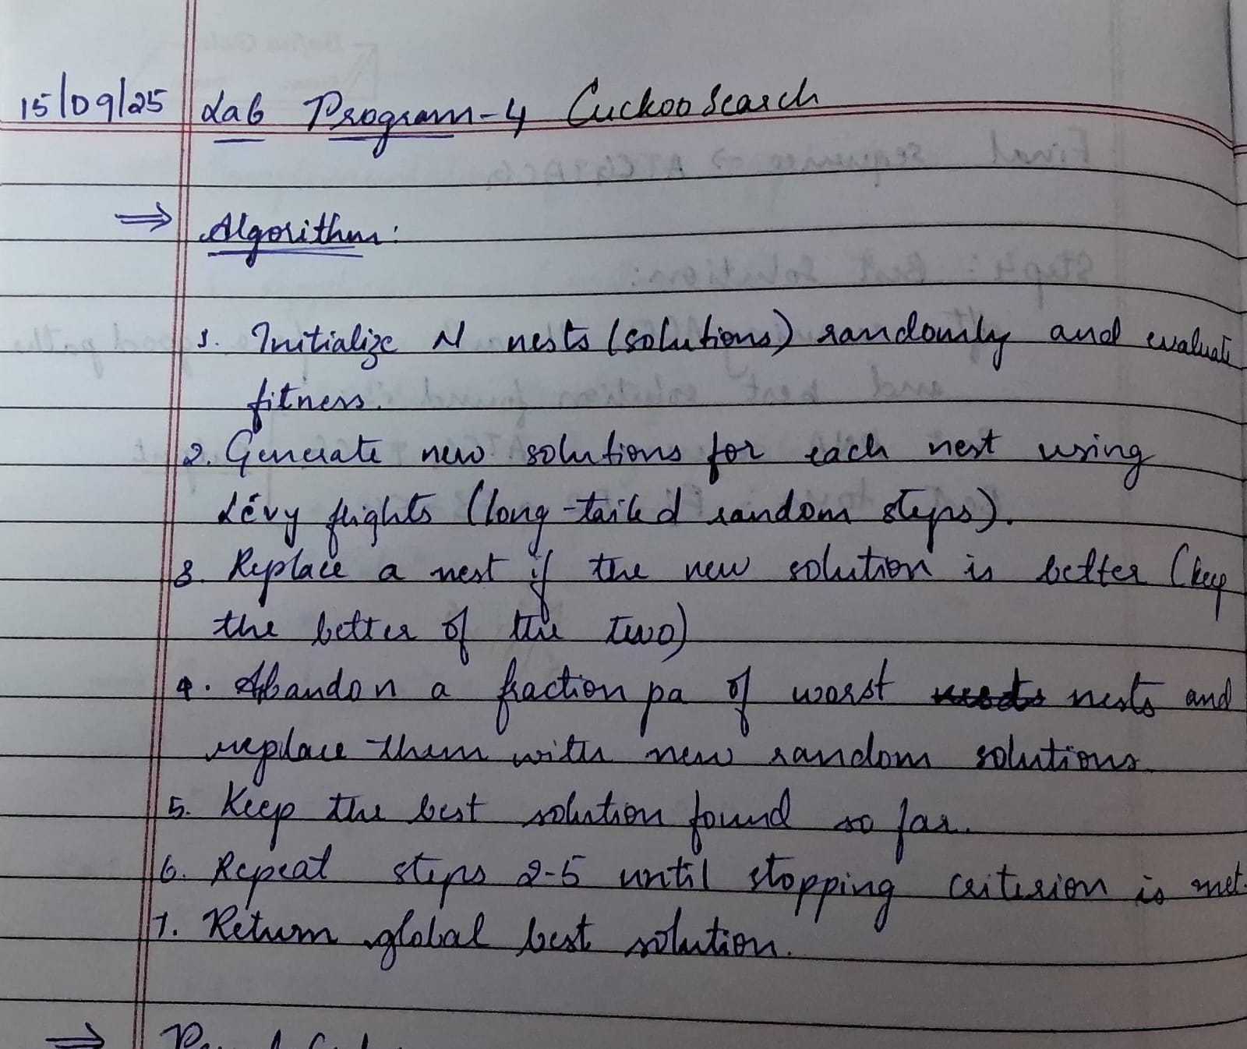

Code:

import numpy as np
import math

# Objective function example: Sphere function
def objective(x):
return np.sum(x**2)

# Generate a random solution within bounds
def random_solution(bounds, dim):
return np.random.uniform(bounds[0], bounds[1], dim)

# Ensure solution stays within search space
def ensure_bounds(x, bounds):
return np.clip(x, bounds[0], bounds[1])

# Lévy flight using Mantegna's algorithm
def levy_flight(dim, alpha=0.01, beta=1.5):
sigma_u = (math.gamma(1+beta) * math.sin(math.pi*beta/2) /
(math.gamma((1+beta)/2) * beta * 2**((beta-1)/2)))**(1/beta)
u = np.random.normal(0, sigma_u, dim)
v = np.random.normal(0, 1, dim)
step = u / (np.abs(v)**(1/beta))
return alpha * step

# Cuckoo Search main function
def cuckoo_search(objective, dim, bounds=(-5,5), n_nests=25, pa=0.25,
alpha=0.01, max_iter=500):

# 1. initialize nests
nests = [random_solution(bounds, dim) for _ in range(n_nests)]
fitness = np.array([objective(x) for x in nests])
best_idx = np.argmin(fitness)
best = nests[best_idx].copy()

for _ in range(max_iter):
# 2. generate new solutions with levy flights
for i in range(n_nests):
new = nests[i] + levy_flight(dim, alpha) * (nests[i] - best)
new = ensure_bounds(new, bounds)
f_new = objective(new)

# 3. greedy selection
if f_new < fitness[i]:
nests[i], fitness[i] = new, f_new
if f_new < fitness[best_idx]:
best_idx = i
best = new.copy()

# 4. abandon a fraction of worst nests
K = int(pa * n_nests)
worst_indices = np.argsort(fitness)[-K:]
for idx in worst_indices:
nests[idx] = random_solution(bounds, dim)
fitness[idx] = objective(nests[idx])
if fitness[idx] < fitness[best_idx]:
best_idx = idx
best = nests[idx].copy()

return best, fitness[best_idx]
if __name__ == "__main__":
dim = 5
best_sol, best_fit = cuckoo_search(objective, dim, bounds=(-5,5),
n_nests=30, max_iter=500)
print("Best solution:", best_sol)
print("Best fitness:", best_fit)

Lab Program 6:

Problem Statement: To find the optimal solution of a given mathematical function using the Grey Wolf Optimizer algorithm. The algorithm is inspired by the leadership hierarchy and hunting behavior of grey wolves, where alpha, beta, and delta wolves guide the search process while other wolves update their positions to converge toward the best solution.

Algorithm:

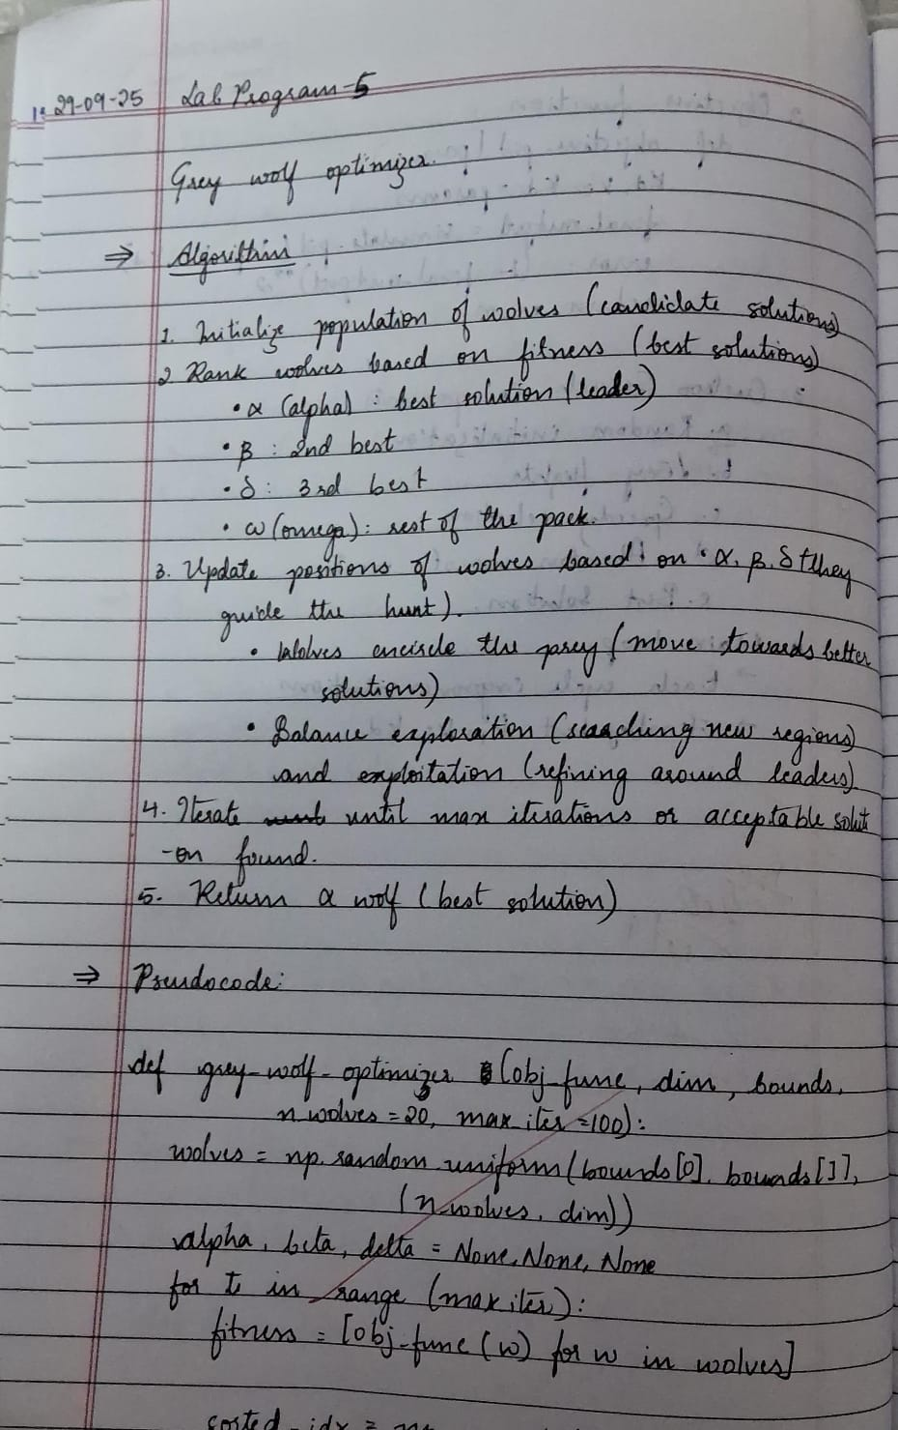

Code:

import numpy as np

# Objective function (Sphere)
def objective_function(x):
return np.sum(x**2)

def grey_wolf_optimizer(obj_func, dim, bounds, n_wolves=20, max_iter=100):
# Initialize wolf positions
wolves = np.random.uniform(bounds[0], bounds[1], (n_wolves, dim))

# Initialize alpha, beta, delta
alpha_pos = np.zeros(dim)
beta_pos = np.zeros(dim)
delta_pos = np.zeros(dim)
alpha_score = float("inf")
beta_score = float("inf")
delta_score = float("inf")

for t in range(max_iter):
for i in range(n_wolves):
# Ensure within bounds
wolves[i] = np.clip(wolves[i], bounds[0], bounds[1])

# Calculate fitness
fitness = obj_func(wolves[i])

# Update alpha, beta, delta
if fitness < alpha_score:
delta_score, delta_pos = beta_score, beta_pos.copy()
beta_score, beta_pos = alpha_score, alpha_pos.copy()
alpha_score, alpha_pos = fitness, wolves[i].copy()
elif fitness < beta_score:
delta_score, delta_pos = beta_score, beta_pos.copy()
beta_score, beta_pos = fitness, wolves[i].copy()
elif fitness < delta_score:
delta_score, delta_pos = fitness, wolves[i].copy()

# Update wolves
a = 2 - 2 * (t / max_iter) # Decreases from 2 to 0
for i in range(n_wolves):
for leader_pos in [alpha_pos, beta_pos, delta_pos]:
r1, r2 = np.random.rand(dim), np.random.rand(dim)
A = 2 * a * r1 - a
C = 2 * r2
D = abs(C * leader_pos - wolves[i])
X = leader_pos - A * D
wolves[i] = (wolves[i] + X) / 2 # average move towards leaders

return alpha_pos, alpha_score

# Test the GWO
best_pos, best_score = grey_wolf_optimizer(objective_function, dim=5, bounds=(-10, 10), n_wolves=20, max_iter=50)

print("Best solution found:", best_pos)
print("Best fitness value:", best_score)

Lab Program 7:

Problem Statement: To find the optimal solution of a given mathematical function using the Parallel Cellular Algorithm. The algorithm is inspired by the behavior of biological cells and uses interactions between neighboring cells in a grid to evolve potential solutions in parallel, allowing efficient exploration of the search space and faster convergence to the optimal solution.

Algorithm:

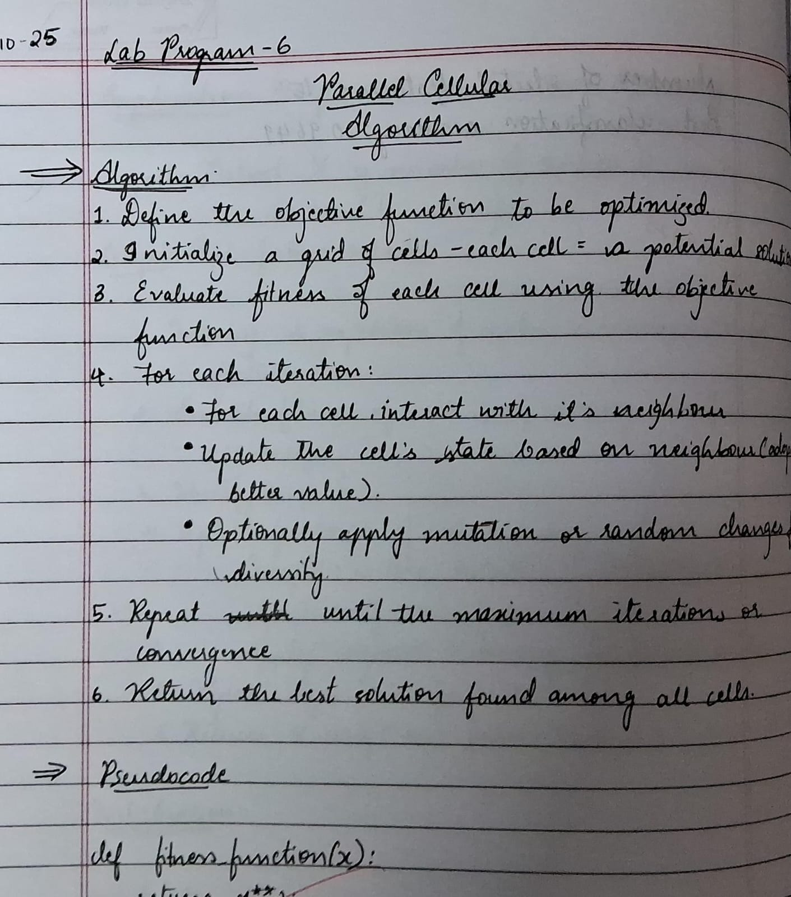

Code:

import numpy as np
import matplotlib.pyplot as plt
import time
import random

# ---------------- Parameters ----------------
GRID_SIZE = 30
INFECTION_PROB = 0.35 # Probability of infection from neighbor
RECOVERY_TIME = 6 # Steps before recovery
ITERATIONS = 40 # Number of simulation steps
VACCINATED_RATIO = 0.1 # 10% vaccinated
QUARANTINED_RATIO = 0.1 # 10% quarantined

# States: 0=Healthy, 1=Infected, 2=Recovered, 3=Vaccinated, 4=Quarantined

# ---------------- Initialization ----------------
grid = np.zeros((GRID_SIZE, GRID_SIZE), dtype=int)
infection_timer = np.zeros((GRID_SIZE, GRID_SIZE), dtype=int)

# Infect one person in the center
grid[GRID_SIZE//2, GRID_SIZE//2] = 1

# Random vaccination and quarantine
for x in range(GRID_SIZE):
for y in range(GRID_SIZE):
r = random.random()
if r < VACCINATED_RATIO:
grid[x][y] = 3
elif r < VACCINATED_RATIO + QUARANTINED_RATIO:
grid[x][y] = 4

# ---------------- Neighbor Helper ----------------
def get_neighbors(x, y):
directions = [(-1,0), (1,0), (0,-1), (0,1)]
neighbors = []
for dx, dy in directions:
nx, ny = x + dx, y + dy
if 0 <= nx < GRID_SIZE and 0 <= ny < GRID_SIZE:
neighbors.append((nx, ny))
return neighbors

# ---------------- Visualization Setup ----------------
plt.figure(figsize=(6,6))
cmap = plt.cm.get_cmap('viridis', 5) # 5 discrete colors for 5 states
plt.ion() # interactive mode

# ---------------- Simulation ----------------
for step in range(ITERATIONS):
plt.clf()
plt.title(f"Disease Spread Simulation (Step {step+1})")
plt.imshow(grid, cmap=cmap, vmin=0, vmax=4)
cbar = plt.colorbar(ticks=[0,1,2,3,4])
cbar.ax.set_yticklabels(['Healthy','Infected','Recovered','Vaccinated','Quarantined'])
plt.pause(0.3)

new_grid = grid.copy()

for x in range(GRID_SIZE):
for y in range(GRID_SIZE):
state = grid[x, y]

if state == 0: # Healthy
for nx, ny in get_neighbors(x, y):
if grid[nx, ny] == 1 and np.random.rand() < INFECTION_PROB:
new_grid[x, y] = 1
break

elif state == 1: # Infected
infection_timer[x, y] += 1
if infection_timer[x, y] >= RECOVERY_TIME:
new_grid[x, y] = 2 # Recovered

# Vaccinated (3) & Quarantined (4) remain unchanged

grid = new_grid.copy()

plt.ioff()
plt.show()
print("\nSimulation complete ")

